
Available online at www.sciencedirect.com
SCIENCE DIRECT
Computer Communications xx (2005) 1-8

www.elsevier.com/locate/comcom
A novel method for QoS provisioning with protection
in GMPLS networks
Tricha A^ali^*, Caterina Scoglio^Electrical and Computer Engineering, Illinois Institute of Technology, Chicago, IL 60616, USA ^{b1}
^{h}Broadband and Wireless Networking Laboratory, Georgia Institute of Technology, Atlanta, GA 30332, USA
Abstract
In this paper, a new optimal policy is introduced to determine, adapt, and protect the Generalized MultiProtocol Label Switching (GMPLS) network topology based on the current traffic load. The Integrated Traffic Engineering (ITE) paradigm provides mechanisms for dynamic addition of physical capacity to optical networks. In the absence of such mechanisms, the rejection of incoming requests may be higher. The objective of the proposed policy is to use ITE to set up virtual tunnels at the MPLS and optical level and protect them against failures. This objective is achieved by minimizing the costs involving bandwidth, switching and signaling. The proposed policy is a computationally non-intensive greedy heuristic with good performance. The new policy operates at two levels: the MPLS network level and the optical network level. Numerical results are presented which show the effectiveness of the policy and the achieved performance. © 2005 Elsevier Ltd All rights reserved.
Keywords: LSP setup; Protection; GMPLS; Network management; QoS
1. Introduction
A multi-service IP network aims to provide Quality of Service (QoS) to different applications and users simultaneously. Such IP networks are becoming feasible with the current advancements in the technology. These advancements include various QoS mechanisms, e.g. Differentiated Service (DiffServ) architecture, MultiProtocol Label Switching (MPLS) etc.; the underlying physical network components, i.e. optical networking technology; and their integration in the form of the multipurpose control plane paradigm of Generalized MPLS (GMPLS). GMPLS is the proposed control plane solution for next generation optical networking. It is an extension to MPLS that enables Generalized Label Switched Paths (G-LSPs) such as lightpaths [1], to be automatically setup and torn down by means of a signaling protocol [2]. GMPLS differs from
* Corresponding author. Tel.: C1 312 567 3383; fax: C1 312 567 3371.
E-mail addresses: tricha@ece.iit.edu (T. Anjali), caterina@ksu.edu
(C. Scoglio).
¹ The work was supported by NSF under award number 0219829. Current address: Electrical and Computer Engineering, Kansas State University, Manhattan, KS, USA.
0140-3664/$ - see front matter © 2005 Elsevier Ltd All rights reserved. doi:10.1016/j.comcom.2005.07.029
traditional MPLS because of its added switching capabilities for lambda, fiber etc. It is the first step toward the integration of data and optical network architectures. It reduces network operational costs with easier network management and operation. The traditional MPLS is defined for packet switching networks only. It provides the advantage of Traffic Engineering (TE) when compared to other routing mechanisms, added to the improved forwarding performance. In other words, MPLS mainly focuses on the data plane as opposed to GMPLS focus on control plane. GMPLS extends the concept of Label Switched Path (LSP) setup beyond the Label Switched Routers (LSRs) to wavelength/fiber switching capable systems. Thus, GMPLS allows LSP hierarchy (one LSP inside another) at different layers in the network architecture. In this hierarchy, the packet switched link is nested inside a lambda switched link which is in turn nested inside a fiber link. GMPLS also performs connection management in optical networks. It provides end-to-end service provisioning for different services belonging to different classes. Its management functionalities include connection creation, connection provisioning, connection modification, and connection deletion. WDM is an optical multiplexing technique that allows better exploitation of the fiber capacity by simultaneously transmitting data packets over multiple wavelengths. IP-over-WDM networks can be
wavelength routed (WR) networks. In WR networks, an all-optical wavelength path is established between edges of the network. This optical path is called a l Switched Path (ISP) and it is created by reserving a dedicated wavelength channel on every link along the path. However, WR networks do not use statistical sharing of resources, and, therefore, provide low bandwidth utilization. To overcome this problem we consider a network architecture where different MPLS networks (for different traffic classes) will be built over the WR network. So each ISP will be assigned to LSPs carrying an aggregation of traffic flows in the same traffic class.
Network reliability plays a key role in the present network design, since a single fiber cut can cause the loss of enormous amount of data. The main objective in designing a reliable network is to provide disjoint back-up paths for LSPs and lambdaSPs in the network. However, a good protection technique has to take into account that resources should be used efficiently and different levels of protection can be provided to different traffic classes. Efficient resource usage can be obtained by providing shared back-up paths subject to the Shared Risk Link Group (SRLG) constraint [3]. According to this constraint, resources cannot be shared by back-up paths whose working paths can fail simultaneously. In determining the shared risk link group, it is reasonable assume a single-fiber failure model. Our network structure, where different MPLS networks are built for different traffic classes, provides the necessary virtual separation of traffic flows which allows us to provide the required level of protection to the LSPs. In general, protection can be provided on-line or can be pre-planned. Since, the on-line approach can lead to delayed establishment of backup paths, we focus on the pre-planned approach.
Many virtual topology design algorithms [4-7] for wavelength routed optical networks have been proposed in literature. A survey of many algorithms of this type is given in [8]. A scheme for optical network design with lightpath protection is given in [9]. A wavelength routing and assignment algorithm for optical networks with focus on maximizing the wavelength utilization at the switches is given in [10]. However, all these algorithms design the network off-line with a given traffic matrix for the network. An on-line virtual-topology adaptation approach is suggested in [11]. This approach is concerned only with the optical network and does not relate the optical topology to the MPLS network topology.
Many approaches for protection have been proposed in the literature. As an example, in [12] two multilayered protection schemes are presented to provide different QoS and recovery requirements both at MPLS and optical layer. In [13], different algorithms for establishing shared backup paths are proposed. Path protection is provided by shared global backup paths and is carried out using partial routing information. The disadvantage with this approach is that global protection requires long recovery time. To overcome this problem, in [14] the whole working path is protected using shared local backup paths, reducing in this way the failure impact. In [3], the use of SRLG is considered as fundamental concept for fault management in layered networks. An SRLG is a group of network links that share common physical resources, whose failure will cause the failure of all the links in the group. The objective is to select a pair of SRLG-disjoint path, one as working path and the other as backup path. In some case, once the working path has been selected, it is not possible to find a SRLG-disjoint backup path, leading to the so called Trap Problem. A fast and efficient algorithm for trap avoidance is also presented
in [3].
The motivation for the development of a combined method to control the topological structure of both the optical network and the MPLS network is based on the concept of Integrated Traffic Engineering (ITE) proposed in [15]. It is a new holistic paradigm for network performance improvement, which consists of viewing the network as an integrated and cohesive system rather than a collection of independent layers. ITE attempts to tie together the key technical activities associated with network performance improvement, by taking a broad view of network performance optimization to encompass domain specific traffic routing and control, resource and capacity management, and economic considerations. The advantages of ITE include cost reduction, greater network adaptability and responsiveness to changing traffic demands, higher quality of service to end users of network services, increased efficiency of network asset utilization, and increased competitiveness. In particular, in the case of IP-MPLS-over-optical networks costs can be further reduced and traffic performance enhanced by establishing direct optical connections between IP routers where substantial traffic demand exists to minimize multi-routing in the IP domain. In this way, the problem of network dimensioning, which traditionally is viewed as a long term planning problem, can be treated as a dynamical operational problem.
The contribution of this paper is a method to dynamically setup, tear-down and protect LSPs and ISPs in response to new traffic demands or failure of the physical infrastructure in order to operate the network more efficiently. In our previous papers [16-18] we introduced a traffic-driven decision policy for on-line design of MPLS and GMPLS networks, but protection was not considered. The policy proposed here will allow the dynamic modification of the virtual topologies both at the MPLS level and at the optical level, while providing efficient protection for the LSPs in the MPLS network and ISPs in the optical network. The proposed policy is based on a greedy algorithm which is effective and simple to be implemented. If the traffic between a given origin-destination pair is less than a threshold Q, that traffic is routed on the shortest path and it is protected by a backup tunnel of capacity equal to Q. When the total traffic exceeds the threshold, a new direct virtual tunnel (LSP or ISP) T1 is created with capacity Q.
If the traffic increases further and the path and the tunnel T1 are fully occupied, another tunnel T2 is setup on a disjoint physical path having the same capacity Q. The tunnel T2 does not require a dedicated additional protection since T1 and T2 do not belong to the same SRLG. In other words, the protection strategy is based on the repartitioning of the traffic in parallel virtual tunnels routed in physically disjoint paths that can share a unique protection tunnel.
The paper is organized as follows. In Section 2, the LSP and ISP setup policy is mathematically formulated. The policy is tested by simulation and the numerical examples are shown in Section 3. Conclusions are given in Section 4.
2. Problem formulation
We now describe the system under consideration. Let G_{ph}(N, L_{ph}) denote a physical fiber network with a set of N nodes and L_{ph} fibers. We define the following notations for
^{G}ph^{(N,} ^{L}ph• l(a, b) 2 L_{ph}: fiber between nodes i and j,
• C: total capacity of fiber l(a, b),
• p(i, j): path between nodes i and j.
We use the notation (a, b) to refer to adjacent nodes and (i, j) for non-adjacent nodes. We assume that there is only one fiber for each link l(a, b) and all the fibers in the network are identical with equal capacities. We assume that Wavelength Division Multiplexing (WDM) is used in the optical domain to simultaneously transmit data over different wavelengths on one fiber. The single fiber assumption provides only one occurrence of any wavelength between a node pair. We also assume that the network does not have any wavelength converters. A virtual end-to-end connection can be established in the optical layer between any node pair of the physical layer (even if they are not connected physically) using lightpaths. A lightpath is defined as an all-optical path between a node pair. In the context of the GMPLS networks, this lightpath is also called as a l Switched Path (ISP) and it is created by reserving a dedicated wavelength channel on every link along the path. We will use the two terms interchangeably. Due to the absence of the wavelength converters, the lightpath is constrained to occupy the same wavelength on all fibers. The virtual network consisting of the lightpaths as the links is denoted by G_{opt}(N, L_{opt}) and we define the following notations for this network:
• Z: number of wavelengths on each fiber (provided by
WDM),
• W: capacity of each data channel on the fiber (provided
by WDM),
• LP_{p1}(i, j) 2 L_{opt}: lightpath between nodes i and j using wavelength 1 over path P.
Note that the total capacity assigned to any lightpath is equal to W, the data channel capacity on the fiber. Also, C= ZW since, a maximum of Z lightpaths can be established on one fiber. Corresponding to each fiber l(a, b) in the physical network, we define a default lightpath LP₀(a, b). Thus, the default lightpaths are single-hop lightpaths between the nodes that are physically connected. Since, these default lightpaths exist only for adjacent nodes, it can be assumed that all of them occupy the same wavelength 1₀ on the respective fibers. Thus, the wavelength 1₀ is reserved for the default lightpath on each fiber. The default lightpaths have a capacity of W, equal to all the other lightpaths in the network.
In the GMPLS environment, the user traffic is switched using MPLS technology at the topmost level. Thus, a virtual MPLS network G_{MPLS}(N, L_{MPLS})isoverlaidonthe lightpath network. Each Label Switched Path (LSP) in the MPLS network corresponds to a set of lightpaths in the optical domain. We define the following terminology for the
MPLS network:
• LSP_{p}(i, j): LSP between nodes i and j overlaying the physical path p(i, j),
• Cp(i, j): Capacity of LSPp(i, j),
• A_{p}(i, j): Available bandwidth on LSP_{p}(i, j),
• B(i, j): Total traffic between routers i (source) and j (destination).
Similar to the optical network, we define default LSPs in the MPLS network. A default LSP0(a, b) is routed on the default lightpath LP₀(a, b) between the adjacent node pair a and b. The default LSPs are assigned a capacity equal to the threshold Q which we will determine later. The rest of the capacity of the default lightpath is used to carry other direct
LSPs.
In the optical network, each 1SP must be routed over fibers in G_{ph}(N, L_{ph}). We assume that the shortest path P_{ph}(i, j) between a source node i and destination node j is the minimum hop path in G_{ph}(N, L_{ph}) and is denoted by
Pph(i,j) = u),l(v,j)}.
In the MPLS network, each LSP must be routed over lightpaths in G_{opt}(N, L_{opt}). We assume that the path P_{opt}(i, j) between a source node i and destination node joverlays the minimum hop path P_{ph}(i, j)inG_{ph}(N, L_{ph}) and is denoted by
Popt(i, j) = {LP0(i, u), LP0(v, j)}.
All the bandwidth requests between i and jare routed either on the direct LSP(i, j)oronP(i, j), a concatenation of multiple default LSPs overlaying P_{opt}(i, j), where
P(i, j) = {LSP0(i, u), LSP0(v, j)}.
We denote by h(i, j) the length of P(i, j). For each possible source-destination pair (i, j) in the MPLS network, we assume that a path LSP_{prot}(i, j) has been selected to provide protection in the MPLS network. We choose
the path LSPprot(i, j) such that it is completely (node and link) disjoint from the shortest path P_{ph}(i, j). Since, we are considering single fiber/node failures in this paper, it is safe to assume that the disjoint path selection assures protection against any possible network failure. All the LSP_{prot}(i, j) (corresponding to the protection paths) are established in the network from the very beginning. These LSPs are not used as working paths but they provide dedicated protection for any traffic between the node pair i and j.
2.1. LSP and lightpath setup policy
When a new bandwidth request b_{m}(i, j) arrives between routers i and j in the MPLS network, the existence of a direct LSP between i and j is checked initially. If a direct LSP is found between i and j, then its available capacity A_{p}(i, j)is compared with the request b_{m}(i, j). If A_{p}(i, j) > b_{m}(i, j), then the requested bandwidth is allocated on that LSP and the available capacity is reduced accordingly. On the other hand, if the LSP available capacity is less than the requested bandwidth, then the request b_{m}(i, j) is routed on P(i, j), the concatenation of default LSPs on the min-hop path between i and j. If no direct LSP exists between i and j, the initial bandwidth requests are granted on the path P(i, j), until a threshold Q is reached. The following bandwidth request leads to the creation of a new direct LSP between i and j. This new LSP is assigned a capacity equal to Q and all the previous requests are re-routed on the new LSP. This LSP is routed on a path which is completely disjoint from the min-hop path P(i, j) and the protection LSP LSP_{prot}(i, j). Future requests are granted on this LSP until the traffic reaches the capacity of the LSP, when another disjoint direct LSP is created. In this manner, we have a set of disjoint LSPs between i and j, each with equal capacity Q. Thus, the total traffic B(i, j) between the nodes can be split into two components: BL(i, j) routed over the various LSPs and BP(i, j) routed over the path P(i, j). The total traffic between the node pair has thus been quantized into modules of size Q(i, j). Each of these modules is routed on a path that is disjoint from the others. Since, the LSP protection path was established with a capacity equal to this module size, we are able to provide protection, at the MPLS level, for all traffic in case of a single fiber failure in the network. In case of a fiber failure, only one of the parallel direct LSPs or the path P(i, j) between nodes i and j will suffer and the corresponding traffic can be easily protected by re-routing on LSP_{prot}(i, j). Thus, we provide dedicated protection for all traffic in case of a single fiber failure. The failure of a single fiber/node in the physical network will actually affect multiple node pairs whose traffic is routed over the failed element. Thus, a single failure in the physical network corresponds to multiple failures in the MPLS network. Each of the node pairs affected by the failure are protected by their own LSP_{prot}(f, g). When an LSP will be fully unutilized as a result of the departure of a request, that LSP is torn-down. However, the default LSPs are never removed.
When we are not able to find another disjoint path in the MPLS network for a direct LSP, we move the protection function to the optical layer. This is achieved by merging all the traffic between the node pair into one LSP which is routed over a direct 1SP over the path P_{ph}(i, j) and creating a backup lightpath LP_{prot}(i, j). This backup lightpath is created such that it is link and node disjoint from the path P_{ph}(i, j). In this manner, the protection is now provided at the optical level. The advantage of this approach is that when the traffic is less, the protection is at the MPLS level, and so the amount of bandwidth reserved for the backup path is less. When the traffic starts to grow, the protection is provided at the optical level since the wastage in the reserved bandwidth will not be too high.
To illustrate the operation of the proposed algorithm, consider the network topology shown in Fig. 1. We consider traffic from node i to node j. Initially, the traffic between these nodes is routed along P(i, j) with protection provided
at the MPLS level using LSPprot(i, j). The LSPprot(i, j)is
routed on a path that is physically disjoint from P(i, j). Further traffic is routed on P(i, j) until the total traffic is greater than or equal to Q. At this point, a new direct LSP LSP₁(i, j) is created between the node pair. Note that the physical path over which this LSP is created is completely disjoint from the paths taken by P(i, j) as well
as LSPprot(i, j). LSPs parallel to LSP1(i, j) (such as LSP2(i,
j)) will be created if the traffic on the path exceeds the threshold Q again. Thus, the single LSP LSPprot(i, j) provides protection to all the traffic between i and j in case of a single link failure. The protection functionality is switched to the optical layer when there are no more disjoint paths between i and j in the MPLS network. Next, we provide the mathematical framework to determine the value of the threshold Q based on the network traffic.
2.2. Policy threshold determination
We assume that the events and costs associated with any given node pair i and j are independent of any other node pair. This assumption is based on the fact that the new bandwidth requests are routed either on a direct LSP between the source and destination or on P(i, j), i.e. the other LSPs are not utilized for routing the new request. This assumption allows us to carry the analysis for any node pair and be guaranteed that it will be true for all other pairs. Under this assumption, we can drop the explicit (i, j) dependence of the notations.
Set of States: For each router pair i and j in the MPLS network, the state vector s_{m} at the time instant t_{m} is defined
as
s = [k,Ap1,Ap2,Apk,Bp]. (1)
where k is the number of parallel LSPs between the node pair, A_{pn} is the available capacity on the n-th LSP routed along p_{n} and B_{P} is the traffic on the path P. The size of the state vector is dependent on the number of parallel LSPs. Note that at any
Fig. 1. Example.
instant of time, the total number of state vectors is N*(N— 1) where N is the number of nodes in the network.
Set of Actions: Assume that at time instant tm, a request b_{m}(i, j) arrives. The decision of setting up a new direct LSP is needed only when no direct LSP exists. This is because once the first LSP is established, all the future LSPs will be created with a capacity equal to the first LSP. The future LSPs will be created only if the existing LSPs and the path are full and cannot take any more traffic requests. The capacity of the future LSPs is equal to the capacity of the first LSP. The decision of setting up the first LSP is captured by the binary action variable a, with a= 1 meaning that the direct LSP will be set-up to accommodate the entire traffic between the node pair and a = 0 meaning that no action will be taken and the request is routed on the multi-LSP physical shortest path in the MPLS network.
Cost Function: We define an incremental cost function W(s, a) associated with the system when a bandwidth request b_{m}(i, j) arrives at time instant t_{m} and the action a is taken. It is the sum of four components as:
W(s, a) = Wb(s, a) C Ww(s, a) C W_{d}gn(s, a) C W^n, (2)
where W_{sign}(s, a) is the cost for signaling the set-up of the LSP to the involved routers, W_{b}(s, a) is the cost for the carried bandwidth, W_{sw}(s, a) is the cost for switching of the traffic and W_{conn} is the cost attributed to the degree of connectivity of the network. The cost components depend on the system state and the action taken for an event.
The bandwidth and switching cost components are incurred for the entire duration of the event and so they
are time-dependent. We assume that a typical network topology provides few paths between a node pair that are equal in length to the shortest path and are disjoint from the shortest path. Thus in our case, we can assume that all the LSPs have equal length h as the min-hop path P. Thus, the cost of carrying a bandwidth request in the network is the same irrespective of whether the traffic request is routed on P or on a direct LSP. This cost is given as
Wb(s, a) = cbhBT,
(3)
where c_{b} is the bandwidth cost coefficient per capacity unit, h is the length of the path, B is the total traffic between the node pair and T is the duration till the next event occurs.
The switching cost depends linearly on the number of switching operations in IP or MPLS mode. The total number of switching operations is h with the assumption that multiple equal length disjoint paths were found. Whether these switching operations are IP or MPLS depends on the path chosen in the MPLS network. For the direct LSP, 1 router performs IP switching and [h—1] routers perform MPLS switching. If no direct LSP exists, h routers perform IP switching because the traffic is carried on individual
default LSPs in P.So
Wsw(s, a) = [cip C cmpls(h — 1)] BlT C hqpBp T,
(4)
where c_{ip} and c_{mpls} are the switching cost coefficients per c.u. per time in IP and MPLS mode, respectively, and B_{L} and B_{P} are the traffic on the LSPs and P, respectively.
The signaling cost W_{sign}(s, a) is incurred instantaneously only when action a= 1 is chosen for state s. It accounts for
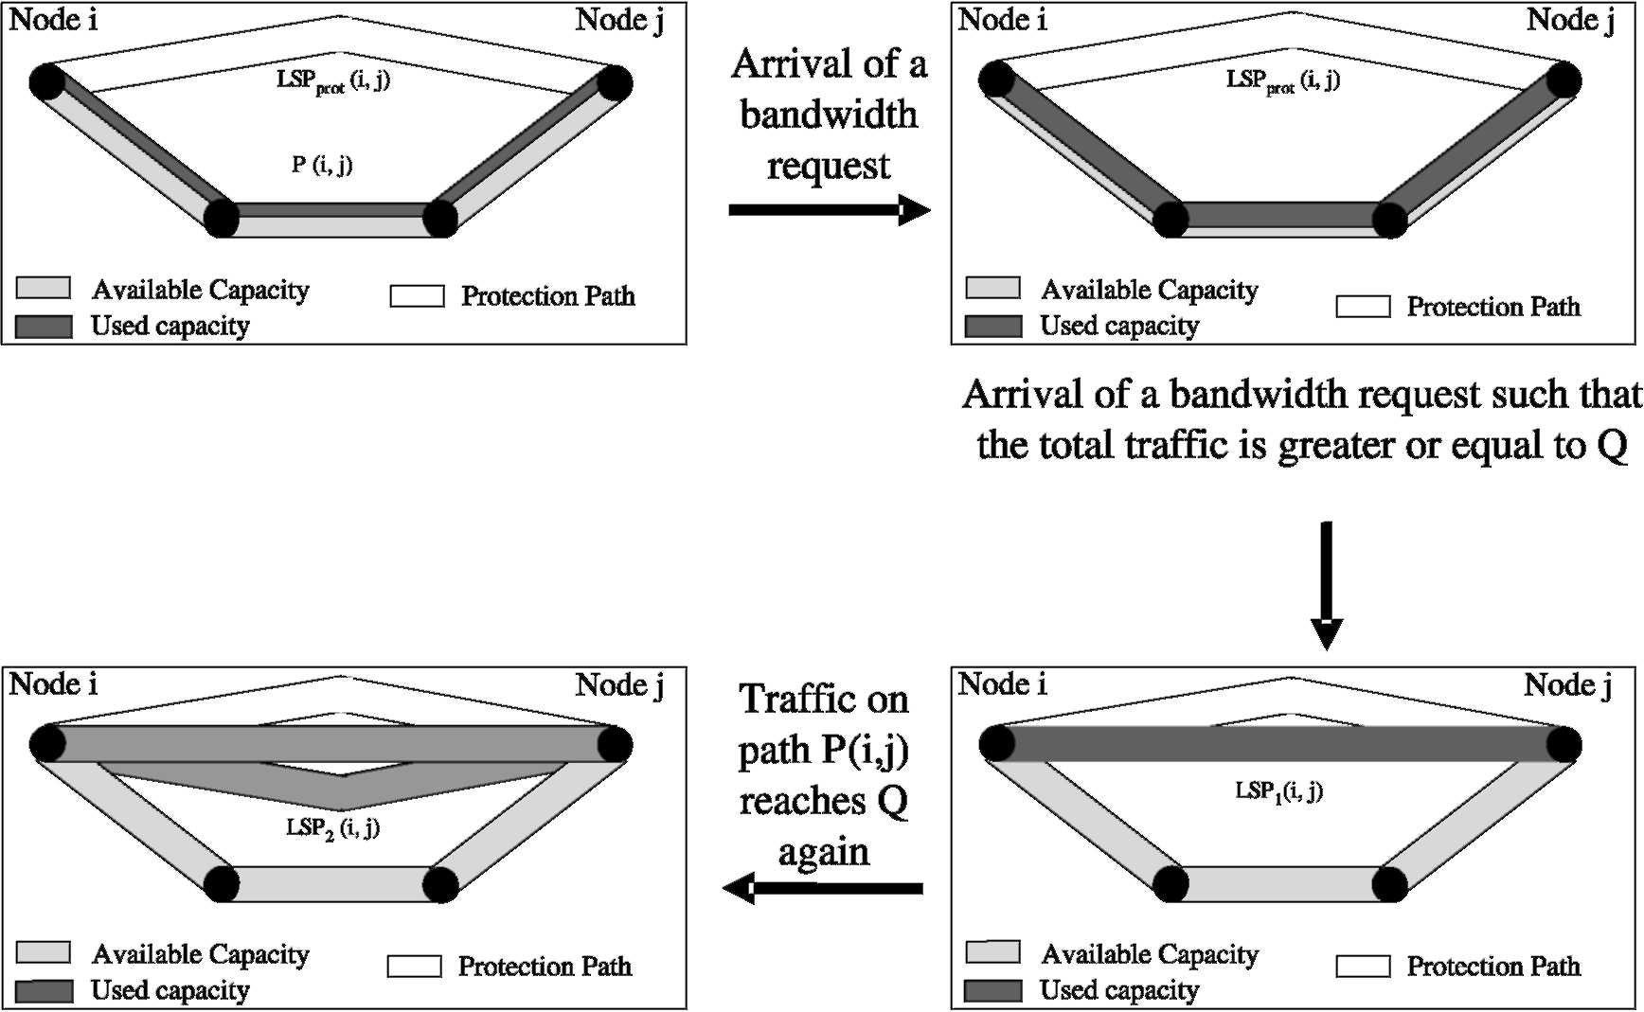
the signaling involved in the process of setting-up of the LSP. We consider that this cost depends linearly on the number of hops h in P_{ph} over which the LSP is routed, plus a constant component to take into account the notification of the new capacity of the LSP to the network.
Wsign(s, a) = a[csh C
(5)
where c_{s} is the coefficient for signaling cost per hop and c_{a} is the fixed notification cost coefficient. This cost is not incurred if a= 0.
The connectivity cost W_{conn}(s, a)isalsoincurred instantaneously only when action a= 1 is chosen for state s. It accounts for the degree of connectivity of the network. If the network is highly connected, it is possible to find more disjoint paths between a node pair. Thus, this component is inversely related to the degree of connectivity of the network.
(6)
where c_{conn} is the coefficient for connectivity cost and d is the degree of connectivity of the network.
Summarizing, the signaling and connectivity costs are incurred only at decision instants when a= 1, while the bandwidth and switching costs are accumulated continuously until a new event occurs. Based on this cost structure, we now propose the LSP and lightpath setup policy to provide protection in GMPLS networks.
Let us assume that a request for allocating bandwidth b_{m} arrives at instant t_{m}. If there is no direct LSP between i and j, a decision has to be made whether to set-up a new LSP or to route the request on the multi-hop physical path. At instant t_{m}, the decision is taken about the value of a_{m} (a_{m}2 {0, 1}). The decision process involves a trade-off between the network resources utilized by the routing path and the signaling and processing load incurred due to the LSP setup.
We denote by a the policy which is the sequence of actions in each decision instant, i.e. a={a₀, a₁,.,a_{M}}. Then in the interval of analysis [0, t_{M}), assuming that the initial state is s₀, the total cost is
M M
V(s0, M, a) =J2 W(Sm, a) = J2 Wb(Sm, a) C Wsw(Sm, a)
m=0
m=0
^{):}
^{C} ^{W}sign^{(S}m, ^{a)} ^{C} ^{W}conn^{(S}m, (7)
Let s_{m} denote the state vector at the instant t_{m} when the decision about LSP set-up is to be made. Let us assume that the action a_{m} taken at instant m depends only on the current state and not on the time of the decision. The decision is based on the following greedy criterion:
(8)
and the total cost will be V(s₀, M, a^{a).}
*)= ^{pM}=₀ W* (s_{m}, a*m⁾ Ve[1,M]. Our LSP setup policy is
given by a = a₀ , . , am, . , a_{M} where am is given as:
_{c} _{hC} _{c} _{C} _{c}
d
1ifB> Q, where Q =
0
^{(c}ip— ^{c}mpls^{)(h—} otherwise
Thus, the value of the threshold Q(i, j) for any node pair is based on the cost coefficients and the length of the minimum hop path between the nodes. This value can be calculated a priori and stored for each node pair.
In the next section, we present the results for simulations used to validate the performance of the proposed policy.
3. Numerical results and discussions
We have introduced the cost coefficients in the cost definitions to provide a relative weight to each of the cost components. A network operator can decide these coefficients based on the fraction of the total cost that is attributed to each cost component. For example, if the bandwidth is a scarce resource in the network, then the bandwidth cost coefficient c_{b} can be assigned larger value to ensure that bandwidth wastage in minimized in the network. A study to assign values to these cost coefficients based on network characteristics is out of the scope of this paper. However, in the following, we have assigned values to these coefficients that we deemed appropriate. In our model, the cost functions are assumed to be linear with respect to the bandwidth requirements of the requests. By keeping a history of user requests, the average inter-arrival time and connection duration can be estimated. The value for the time duration of the LSP can be obtained from past statistics of the traffic and the network. Note that we assume no wavelength converters are available in our optical network.
For the simulations, we used the physical topology of Fig. 2 with 40 nodes and 64 links. This topology has an average node connectivity of 3.2. We hypothesize that on an average, the number of disjoint paths between any node pair in a network is close to the average node degree in the network. Each node in the network represents an LSR and each edge represents a fiber link connecting two LSRs. Each fiber has a capacity of C=600 Mbps (OC-48). We assign a capacity of W= 50 Mbps to each 1SP. The cost coefficients are chosen as c_{s}= 2, c_{a}= 2, c_{b}= 2, c_{ip}= 1, c_{mpls}= 0.5, c_{conn}= 5. Note that we have assigned values such that c_{ip}> c_{mpls} and the signaling and connectivity costs are larger than any of the other costs.
To evaluate the performance of the proposed algorithm, we will compare its performance with a simple policy called as fixed policy. According to this fixed policy, instead of calculating the threshold based on the various cost components, the capacity of the parallel LSPs is fixed
_{W} (_{s} _{a}\ = am : W* (s_{m}, a^) = min W(s_{m}, a_{m}) V m e [0 , M],
¹⁾
^{aCconn}
ªm 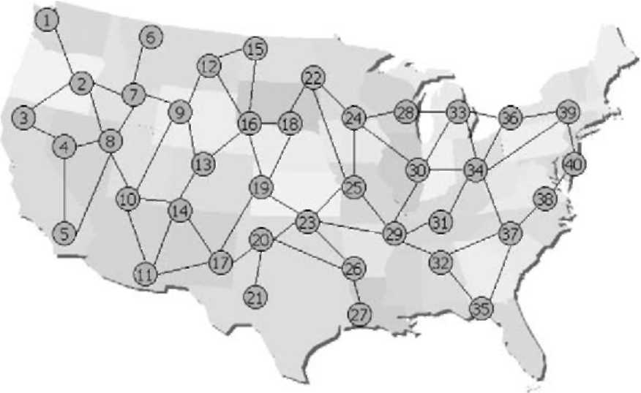
Fig. 2. Network topology.
a priori based on a pre-analysis of the network topology. Suppose, for a give node pair, we find that there are r\ disjoint paths. One of these paths is used for routing the backup LSP. The LSP capacity is calculated as W/(h — 1) where W is the capacity of the lightpath. In this manner, r\ — 1 LSPs are established, as needed, such that their total capacity equals the lightpath capacity. This fixed policy does not depend on the cost coefficients for the LSP capacity calculation.
We model the traffic requests with Poisson process arrivals and exponential durations. We divide the simulations into two broad traffic scenarios to represent significant conditions. These scenarios are characterized by different traffic loads in the network. We consider generalized medium, and focused high traffic loads to bring out the contrast in traffic conditions and observe the effects on the network performance. We define the generalized medium traffic load as traffic matrix with equal values as the elements. On the other hand, the focused high load scenario is represented by a matrix where elements corresponding to node pairs on the opposite extremes of the network have twice the value as other node pairs. We conducted 10 independent simulations with similar traffic profiles and present the results next.
In Fig. 3, we show the cost for carrying the traffic in the MPLS network for the two policies with the medium traffic
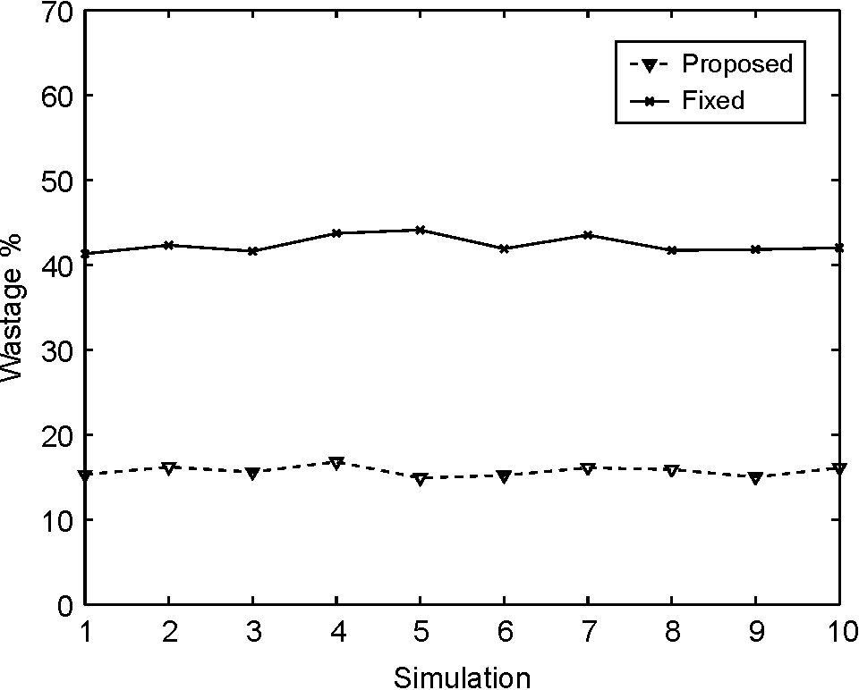
Fig. 4. Unutilized fraction of reserved bandwidth—medium traffic.
load. We see that the proposed policy is able to reduce the cost incurred by the network effectively, when compared to the fixed policy. The average reduction in cost is about 28%. This cost reduction is achieved by the proposed policy because the capacity of the LSPs is lower in the proposed policy which leads to lower bandwidth and switching costs.
In Figs. 4 and 5, we have shown the average wastage of reserved bandwidth in MPLS network for the medium and high traffic scenarios, respectively, for the duration of the simulation. We see that for both the traffic scenarios, the wastage is much lower with the proposed algorithm than the fixed policy. However, the fixed policy fares better for higher traffic loads since the LSP capacity is utilized more.
In the MPLS network, about 20% of the total bandwidth
is reserved for protection purposes by the proposed algorithm, whereas about 37% is reserved by the fixed policy. On the other hand, in the optical network, about 30%
Fig. 3. Cost in MPLS network—medium traffic.
Fig. 5. Unutilized fraction of reserved bandwidth—high traffic.
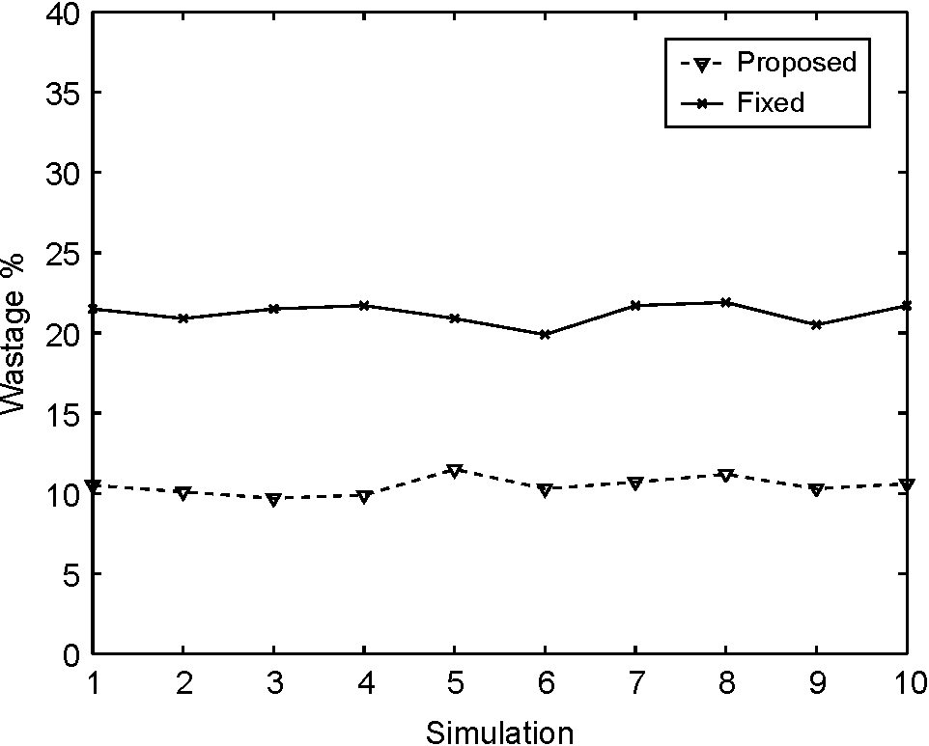
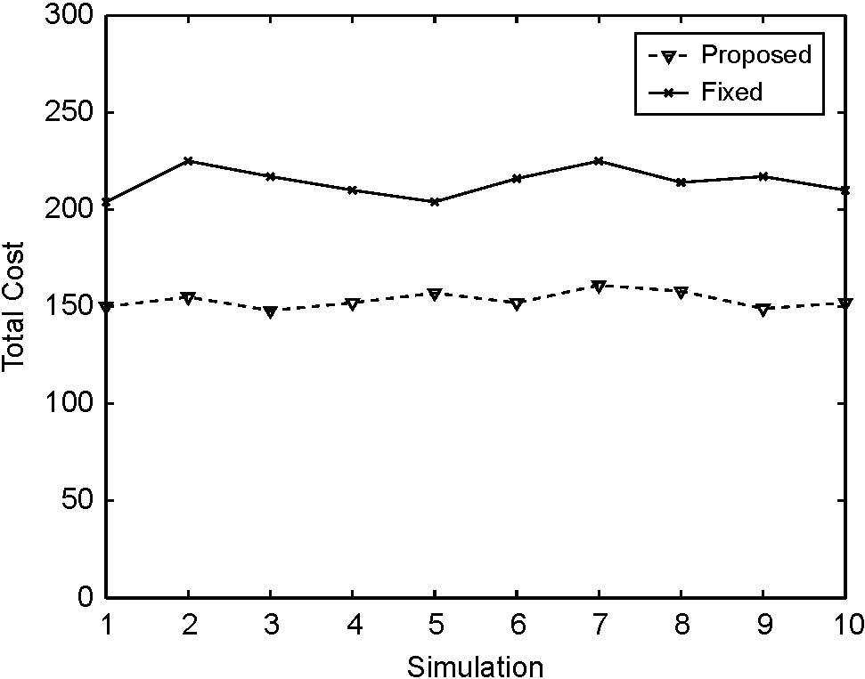
of the total bandwidth is reserved for protection by both the proposed method and the fixed policy. Thus, our policy is better at utilizing the bandwidth in the MPLS network by reducing the wastage of reserved bandwidth and reducing the fraction of bandwidth reserved for protection.
4. Conclusions
In this paper, we presented a new decision policy that provides the on-line design of an MPLS network topology for the current traffic load and pattern, while providing protection for the traffic in case of a single failure in the network.
The proposed policy is based on the network load, which is part of the defined network state, via a threshold criterion. The threshold calculation takes into account the bandwidth, switching, signaling and connectivity costs and depends on the cost coefficients. Furthermore, since a given traffic load mayjust be atemporary phenomenon, ourpolicy also performs filtering in order to avoid oscillations that can be typical in a variable traffic scenario. The optimality of our policy among the set of all admissible policies is an open question and will be dealt with in the context of Markov Decision Processes.
The proposed method was tested by simulation and compared with a simple policy. Several examples were considered. The results confirm that the proposed policy is effective and improves network performance by reducing the cost incurred.
[8] R. Dutta, G.N. Rouskas, A Survey of Virtual Topology Design Algorithms for Wavelength Routed Optical Networks, Technical Report TR-99-06, North Carolina State University, p. 12.
[9] R.D. Davis, K. Kumaran, G. Liu, I. Sainee, SPIDER: a simple and flexible tool for design and provisioning of protected lightpaths in optical networks, Bell Labs Technical Journal (2001) 82-97. [10] C. Chen, S. Banerjee, Optical switch configuration and lightpath assignment in wavelength routing multihop lightwave networks, Proceedings of IEEE INFOCOM'95, Boston, USA, 1995,
pp. 1300-1307.
[11] A. Gencata, B. Mukherjee, Virtual-topology adaptation for WDM mesh networks under dynamic traffic, IEEE/ACM Transactions on
Networking 11 (2) (2003) 236-247.
[12] Q. Zeng, G. Mohan, Protection approaches for dynamic traffic in IP/MPLS-over-WDM networks, IEEE Optical Communications 41
(5) (2003) S24-S29.
[13] M. Kodialam, T.V. Lakshman, Dynamic routing of bandwidth guaranteed tunnels with restoration, Proceedings of IEEE INFO-COM'00, Tel Aviv, Israel, 2000, pp. 902-911.
[14] M. Kodialam, T.V. Lakshman, Restorable dynamic quality of service routing, IEEE Communications Magazine 40 (6) (2002) 72-81.
[15] A. Banerjee, J. Drake, J. Lang, B. Turner, D. Awduche, L. Berger, K. Kompella, Y. Rekhter, Generalizd multiprotocol label switching: An overview of signaling enhancements and recovery techniques, IEEE Communications Magazine 39 (7) (2001) 144-151.
[16] C. Scoglio, T. Anjali, J.C. de Oliveira, I.F. Akyildiz, G. Uhl, A new threshold-based policy for label switched path setup in MPLS networks, Proceedings of 17th ITC'01, Salvador, Brazil, 2001, pp. 1-12.
[17] T. Anjali, C. Scoglio, J.C. de Oliveira, I.F. Akyildiz, G. Uhl, Optimal policy for LSP setup in MPLS networks, Computer Networks 39 (2) (2002)165-183.
[18] T. Anjali, C. Scoglio, I.F. Akyildiz, LSP and ISP setup in GMPLS networks, Proceedings of IEEE INFOCOM'04, Hong Kong, China,
2004.
Acknowledgements
The authors would like to thank Dr. Ian Akyildiz for his constant support and motivation.
References
[1] I. Chlamtac, A. Ganz, G. Karmi, Lightpath communications: an approach to high bandwidth optical WANs, IEEE Transactions on Communications 40 (1992) 1171-1182.
[2] E. Mannie, Generalized multi-protocol label switching (GMPLS)
architecture, IETF RFC 3945, 2004.
[3] D. Xu, Y. Xiong, C. Qiao, G. Li, Failure protection in layered networks with shared risk link groups, IEEE Network 18 (2004) 36-41.
[4] M.A. Marsan, A. Bianco, E. Leonardi, F. Neri, Topologies for wavelength-routing all-optical networks, IEEE/ACM Transactions on
Networking 1 (5) (1993).
[5] D. Banerjee, B. Mukherjee, Wavelength-routed optical networks: linear formulation, resource budgeting tradeoffs, and a reconfiguration study, IEEE/ACM Transactions on Networking 8 (5) (2000) 598-607.
[6] R.M. Krishnaswamy, K.N. Sivarajan, Design of logical topologies: a linear formulation for wavelength-routed optical networks with no wavelength changers, IEEE/ACM Transactions on Networking 9 (2)
(2001).
[7] A. Nucci, B. Sanso, T.G. Crainic, E. Leonardi, M.A. Marsan, On the design of fault-tolerant logical topologies in wavelength-routed packet networks, IEEE Journal on Selected Areas in Communications 222 (9) (2004) 1884-1895.

Tricha Anjali received the (Integrated) M.Tech. degree in Electrical Engineering from the Indian Institute of Technology, Bombay, in 1998 and PhD degree from Georgia Institute of Technology in May 2004. Currently, she is an Assistant Professor at the Electrical and Computer Engineering department at the Illinois Institute of Technology. Her research interests include design and management of MPLS and optical networks.
Caterina Scoglio received the Dr Ing. degree in Electronics Engineering from the University of Rome 'La Sapienza', Italy, (summa cum laude) in May 87. She received a post-graduate degree in 'Mathematical Theory and Methods for System Analysis and Control' from the University of Rome 'La Sapienza', Italy, in
November 88. From June 1987 to June 2000,
she was with Fondazione Ugo Bordoni, Rome, as a research scientist. From September 2000 to May 2005, she was with the 'Broadband and Wireless Networking Laboratory' of the Georgia Institute of Technology as a Research Engineer. Currently, she is an Associate Professor in the Electrical and Computer Engineering department at Kansas State University. Her research interests include optimal design and management of multi-service networks.


